
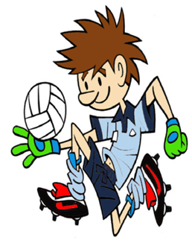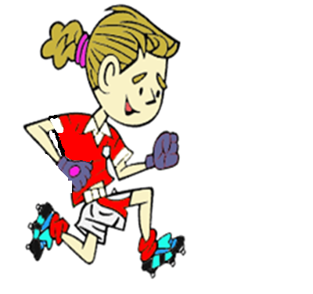
RULES – HOW TO PLAY

Pairs on either side of poles, cones

Children aim to successfully punt kick the ball back and forth as many times as possible in allocated time (1min)

When first player takes his/her kick they move behind partner etc.

1 point is awarded for each successful kick through the poles (Gate)

FOCUS
In this activity the children are being challenged to punt kick the ball through a target
STATION 2: KICKING
Activity: Through the Gate

HARDER
- Make the target gates smaller
- Increase the kicking distance from the Gate
- Use non-preferred foot

EASIER
- Bounce and kick, or kick off the ground or a dome
- Make the targets wider or move closer to the Gate
- Allow ball to bounce before being caught

COACHING POINTS
HEAD
- Head should be over the ball when striking, with eyes fixed on ball throughout
HANDS
- Ball should be dropped ‘off the shelf’ (Let it roll gently off the finger tips) with both hands when kicking initially when learning the skill
- Use 1 Hand drop as skill improves
FEET
- Kicking foot should be ‘hard’, with toe pointing down
- Kick using top of laces
- Follow through with straight leg pointing at the middle of the gate
EQUIPMENT

- Football (one per group)

- Targets domes/poles (two per group)

- Kicking domes (two per group)

Copyright Ulster Council GAA 2009

